Lecture 3 summary PC

2 main categories of parallel computers

1. Shared memory parallel computer- each process has equal access to these memory modules. Most commonly used for multi-core desktop machines

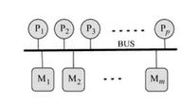

1. Distributed memory parallel computer

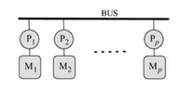

It is a bad idea to only have shared memory parallel computers.

In serial computation, we don’t have as many issues as with non-determinism. The answer would always be 5 in example 2, whilst with non-determinism, it depends on which thread gets executed

Message passing- rank. E.g. if there are p number of processes then the ranks will be from 0 to p-1

Point-to-point communication is basic send and receive functions

The mapping process- parallel program design cont. The program may also control the mapping of processes to processes.